POWER BI PROJECTS

This project involves creating interactive dashboards and reports using Microsoft Power BI for NexaTech Solutions, a startup based in Noida. The system consolidates data from sales, finance, operations, and customer interactions to provide a comprehensive view of business performance. Utilizing Power BI features such as drill-through analysis, KPI tracking, forecasting, and custom visualizations, the dashboards enable management to monitor key metrics, detect patterns, and make data-driven strategic decisions. Project Modules: Sales Dashboard, Financial Performance Analysis, Customer Insights, Operational Efficiency Metrics, Forecasting and Trend Analysis

Power BI Project Modules

Sales Dashboard
- KPIs:
  - Total Sales, Total Profit, Profit Margin %
- Visuals:
  - Bar Chart → Sales by Product
  - Map → Sales by Region/City
  - Column Chart → Sales by Top 10 Salesperson
  - Table → Country, Total Sales, Total Profit, Profit Margin %
- Drill-through: From region → city → individual customer sales.
Financial Performance Analysis
- KPIs:
  - Total Revenue, Total cost, Gross Profit, Total Expenses, Net Profit
- Visuals:
  - Bar Chart → Revenue vs Expenses trend over years
  - Pie/Donut → Expense category breakdown (Office, Logistics, Salaries, Marketing)
  - Matrix Table → Date(Year, Month), Total Revenue, Total cost, Gross Profit, Profit Total expenses, Net Profit
Customer Insights
- KPIs:
  - Total Customers, Customer Sales count, Total sales Count
  - Customer Lifetime Value (CLV)
- Visuals:
  - Map → Customer distribution globally
  - Tree Map → Revenue by Top 10 Customers
  - Column Chart → Total Customer by Region

Operational Efficiency Metrics
- KPIs:
  - Orders Completed vs Pending vs Shipped
- Visuals:
  - Gauge → % Orders On-Time
  - Stacked Bar → Order Status byWarehouse
  - Funnel → Sales pipeline (Quotes → Orders → Shipped → Completed)
Forecasting & Trend Analysis
- Visuals:
  - Line Chart with Forecast → Sales (next 6–12 months)
  - Trend Line → Customer acquisition growth

Dax formula
DateTable =
ADDCOLUMNS (
CALENDAR(DATE(2020,09,1), DATE(2025,09,30)),
//CALENDARAUTO(),
"Year", YEAR([Date]),
"Quarter", "Q" & FORMAT(CEILING(MONTH([Date])/3,1), "#"),
"Quarter No", CEILING(MONTH([Date])/3, 1),
"Month No", MONTH([Date]),
"Month Name", FORMAT([Date], "MMMM"),
"Month Short Name", FORMAT([Date], "MMM"),
"Month Short Name Plus Year", FORMAT([Date], "MMM,yy"),
"MonthSort", FORMAT([Date], "yyyyMM"),
"DateSort", FORMAT([Date], "yyyyMMdd"),
"Day Name", FORMAT([Date], "dddd"),
"Details", FORMAT([Date], "dd-MMM-yyyy"),
"WeekSort", FORMAT([Date], "w"),
"Day Number", DAY([Date])
)

Sales data - Measure
Total Sales = sum('Sales Data'[Amount])
Total Cost = SUM('Sales Data'[Cost])
Gross Profit = [Total Sales] - [Total Cost]
Total Profit = [Total Sales] - [Total Cost]
Profit% = DIVIDE([Total Profit],[Total Sales],0)
Net Profit = [Gross Profit] - [Total Expenses]
Rev_Exp_Ratio = DIVIDE([Total Expenses],[Total Sales],0)
Highest Exp Category =
MAXX(
TOPN(1,
SUMMARIZE('Expenses data',
'Expense Master'[Expense Category],
"Category Total",SUM('Expenses data'[Tax])),
[Category Total],DESC),
'Expense Master'[Expense Category]
)
CLV = AVERAGEX(
VALUES('Customer master'[Customer ID]),
CALCULATE(SUM('Sales Data'[Amount]))
)
Customer Sales count = COUNTROWS(RELATEDTABLE('Sales Data'))
New Customer = CALCULATE(DISTINCTCOUNT('Customer master'[Customer ID]),FILTER('Customer master',[Customer Sales count]=1))
Return Customer = CALCULATE(DISTINCTCOUNT('Customer master'[Customer ID]),FILTER('Customer master',[Customer Sales count]>1))
New Cust =
CALCULATE(
DISTINCTCOUNT('Customer master'[Customer ID]),
FILTER(
'Customer master',
'Customer master'[Customer ID] IN
VALUES('Sales Data'[Customer ID])
)
)

Operation data - Measure
Total Orders = COUNTROWS('Operations Data')
Shipped Orders = CALCULATE(COUNTROWS('Operations Data'),'Operations Data'[Status]="Shipped")
Quotes Orders = CALCULATE(COUNTROWS('Operations Data'),'Operations Data'[Status]="Pending")
Completed Orders = CALCULATE(COUNTROWS('Operations Data'),'Operations Data'[Status]="Completed")
On-Time Orders% = DIVIDE([Completed Orders],[Completed Orders]+[Quotes Orders]+[Shipped Orders],0)

Expenses data - Measure
Total Expenses = SUM('Expenses data'[Tax])

Customer data - Measure
Total Customer = DISTINCTCOUNT('Customer master'[Customer ID])

Dashboard Screenshots:
Home page:
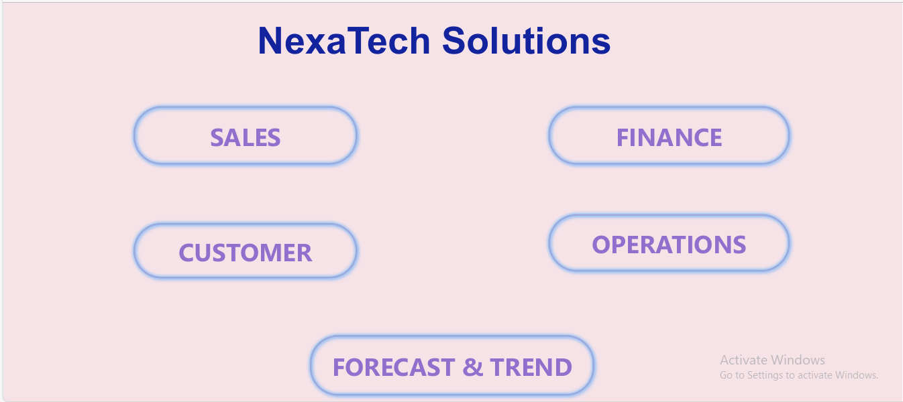

Sales Dashboard:
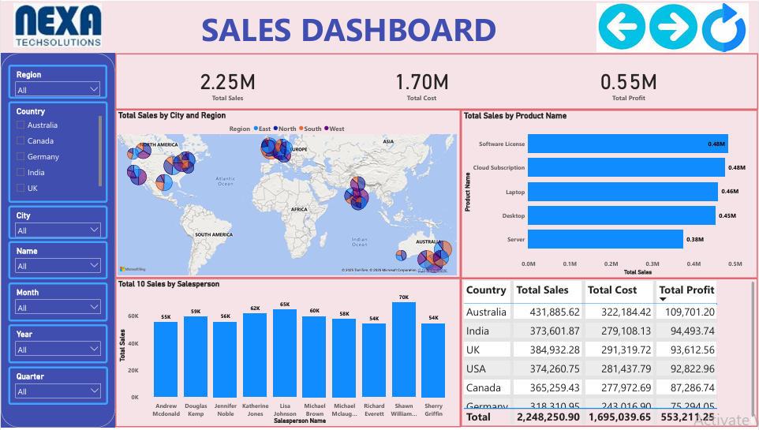

Finance Dashboard:
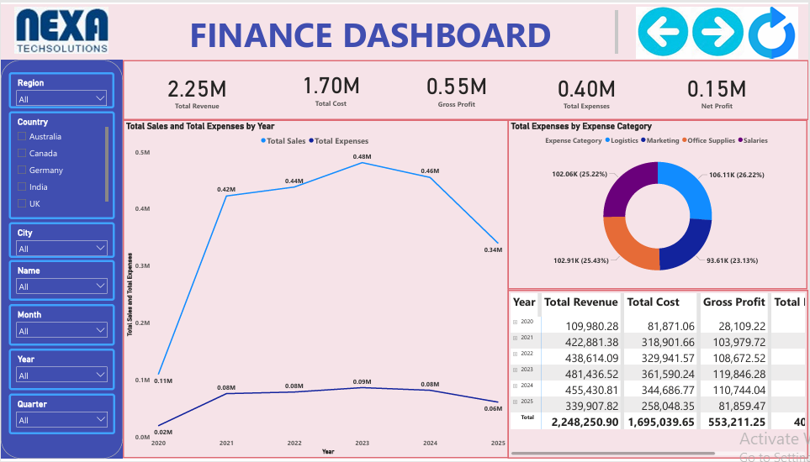
Customer Dashboard:
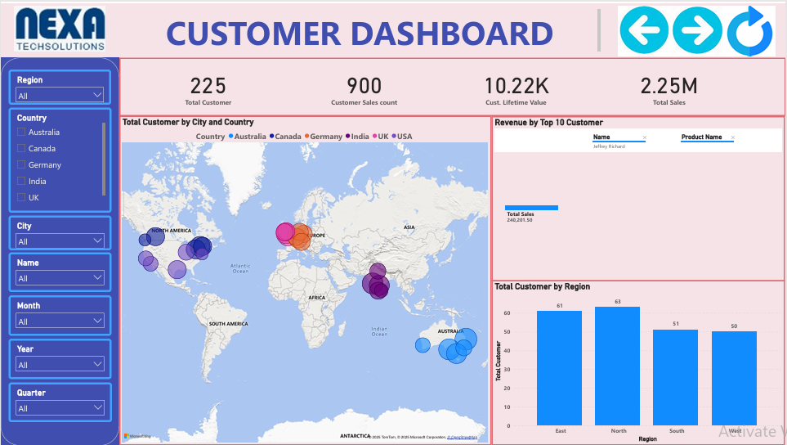

Operation Dashboard:
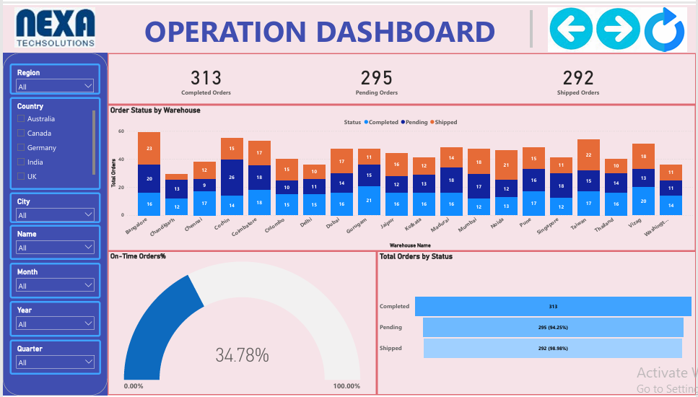

Forecast & Trend analysis Dashboard:
